07/11/24

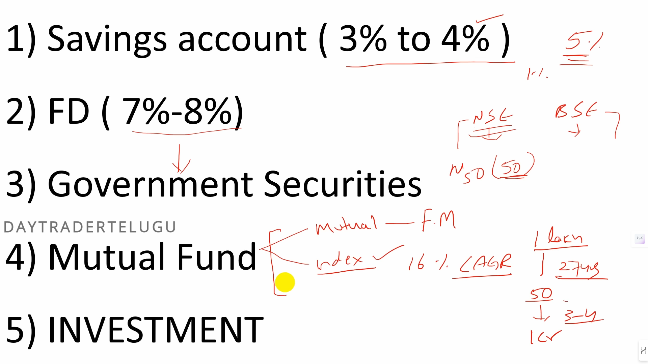

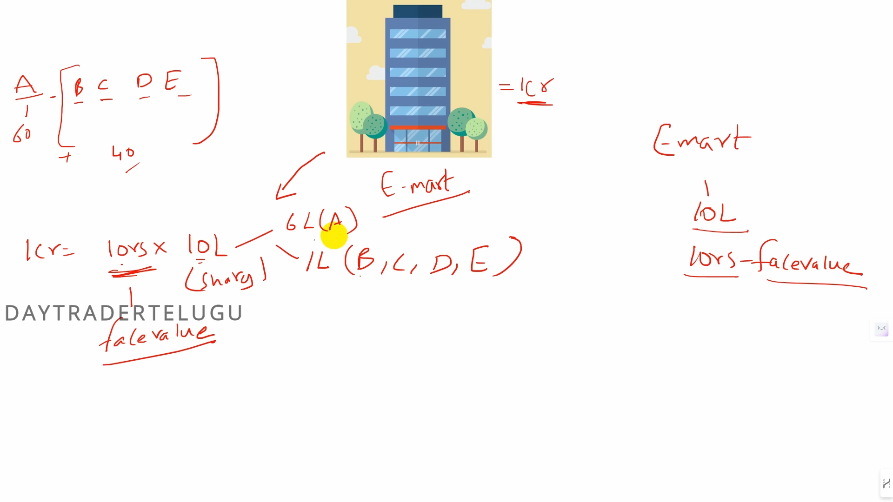

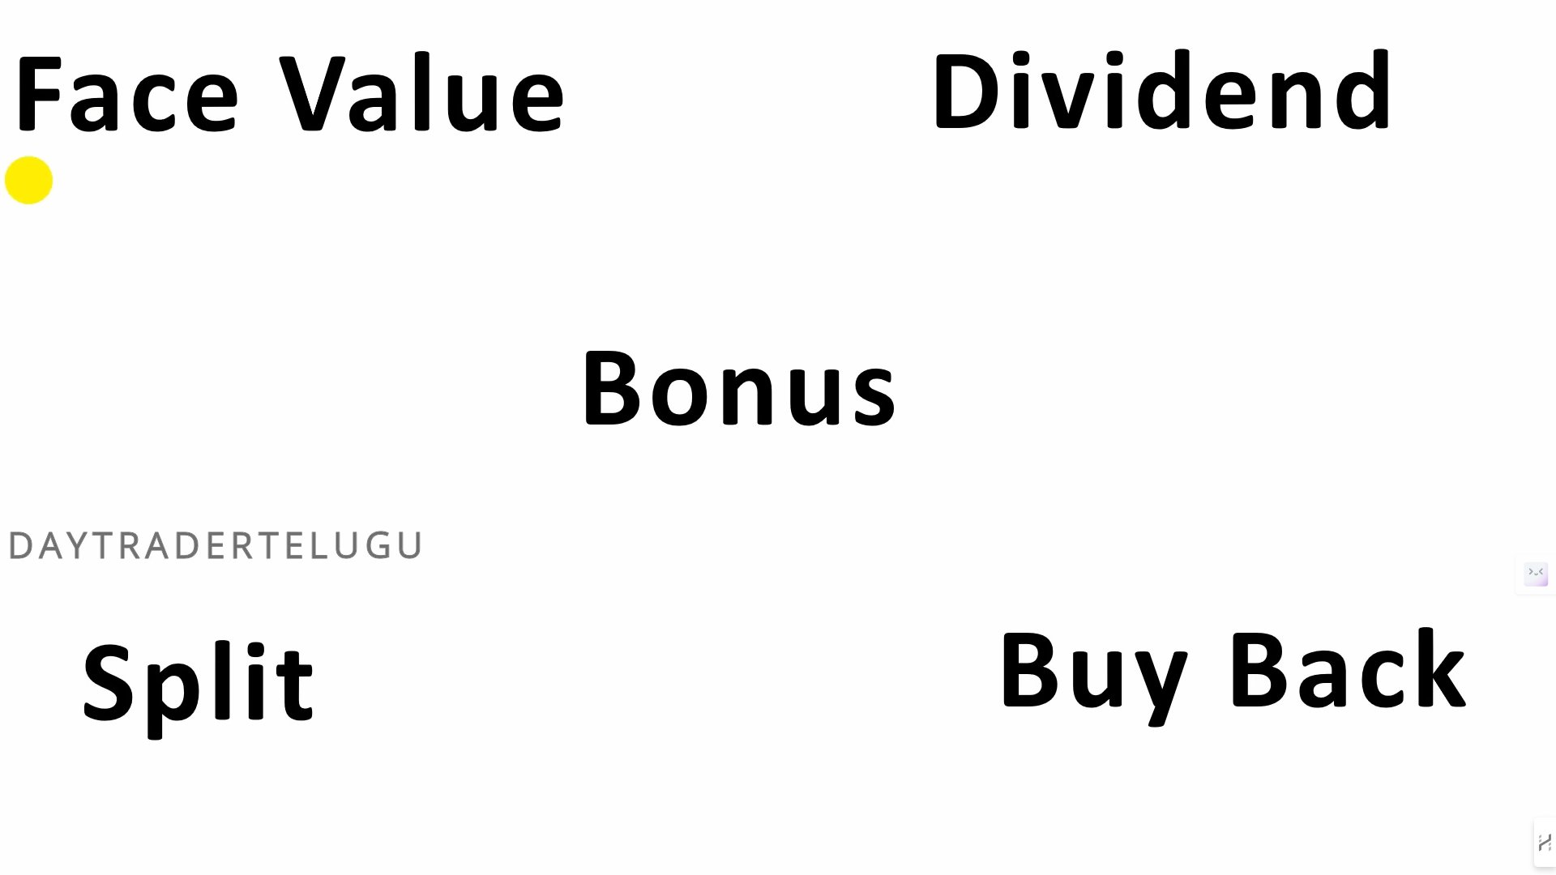

- Money can be invested in many ways. But, what you choose to invest is important.

- Face Value is the Value the Share Price actually holding.

-